**FITNESS WEBSITE**

**A REPORT on project baSED LEARNING**

**(semester -II)**

*Submitted by*

**NAME OF THE CANDIDATE(S)**

PARTH DESHMUKH

AKSHAY PACHKATE

TEJAL KOLHE

SHREYA REPALE

VIRAJ KAKADE

**FIRST YEAR ENGINEERING**



# Society for Computer Technology and Research’s

# PUNE INSTITUTE OF COMPUTER TECHNOLOGY

# DHANKAWADI, PUNE – 43

**A.Y. 2021-22**

**ABSTRACT**

Obesity is a major global challenge. It increases the risk of developing

health problems such as cancer, diabetes and cardiovascular disease.

Its prevalence puts pressure on the healthcare systems and on individual’s health and finances as well.

The use of fitness technology that is fitness websites and apps in supporting health behavior change is promising.

Fitness technology not only expands opportunities for users to access health related information but also facilitate cueing behavior change.

The objective of this paper is to identify the features that should supported by health and fitness websites and fitness wearable devices to encourage individuals to be active, change their lifestyle and to keep them motivated to overcome health related problems.

So basically, our website provides information about different exercises, nutrition and calorie, yoga and meditation, etc.

We have created some fitness calculators that make our website interesting. It contains of a music playlist that consists of songs that keep the user motivated.

All this data is been embedded in the website with the help of HTML.

This information is been made attractive with the help of CSS using different fonts, background images, background colors, templates and lot more. JS is been used in making the fitness calculators.

**ACKNOWLEDGEMENT**

Firstly, we would like to express our gratitude to **Mr. Kaustubh Kulkarni** for his guidance and supervision. He gave us his valuable suggestions and ideas when we needed them and encouraged us to work on this project. Thank you for your continuous support and presence whenever needed.

 We are also grateful to our college**- ‘Pune Institute of Computer Technology’** for giving us the time and opportunity to work on such a project with our peers and providing us the necessary resources for the project

We would also thank to all of them who helped us to complete this project.

 We are immensely grateful to all the individuals who were directly or indirectly involved in this project as without their inspiration and valuable suggestion it would not have been possible to develop the project within the prescribed time.

Place: Name of Student (in Capital) & Sign

**TABLE OF CONTENT**

|  |  |  |
| --- | --- | --- |
| **Chapter No.** | **Title** | **Page No.** |
| **1.** | **Introduction** |  |
| **2.** | **History** |  |
| **3.** | **Objectives** |  |
| **4.** | **Stages of project** |  |
| **5.** | **Conclusion** |  |
| **6.** | **References** |  |
|  |  |  |

Chapter 1

**INTRODUCTION**

The health benefits of regular exercise and physical activity are hard to ignore. Everyone benefits from exercise, regardless of age, sex or physical ability.

Exercise can help prevent excess weight gain or help maintain weight loss. When you engage in physical activity, you burn calories. The more intense the activity, the more calories you burn.

Regular trips to the gym are great, but don't worry if you can't find a large chunk of time to exercise every day. Any amount of activity is better than none at all.

Our fitness website is a health service that helps individuals attain one of the greatest gifts of all-good health. Personal gains such as improved self-esteem, self-motivation combined with measurable benefits will create tremendous advantages for the individuals.

Our fitness website will provide fitness related information truly dedicated to solving the fitness needs of our costumer. This will be done through providing the accurate data, providing a clean and crowd-free environment.

The Home page of the website is made such that it attracts the user due to its beautiful user interface. The home gives the user a brief idea about our website. The home page consists of different sections that can lead the user to explore our website.

Chapter 2

**HISTORY**

Over the last five years use of fitness websites and wearable devices have gained popularity in fitness behavior interventions; especially for individuals who want to lose weight and gain better fitness.

In 2014 the global fitness technology market was estimated to be worth 19 billion U.S dollars.

The use of fitness technology, websites and wearable devices in supporting health behavior change is promising. Health and fitness websites have grown rapidly over the years and there are more than thirty-one thousand fitness apps available on the internet.

There is a growing interest in how the role of fitness websites and wearable devices can influence the behavior of individual. Fogg introduced a framework called the “functional triad” that describes the role of devices in the device-human interaction.

He also highlights that devices can motivate humans by being mediums, social actors or tools.

For example, fitness websites can act as predisposing factors or tools to diffuse fitness information. They can also collect personal information about the user’s behavior. These apps also connect the user to social networks.

Chapter 4

**OBJECTIVES**

* To help fitness enthusiast with workout and nutrition information.
* To spread awareness about fitness.
* To make easy excess of information about fitness.
* To help beginner to achieve fitness goal.
* To develop a community network for wellness promotion.
* Be able to take knowledge that is learned regarding wellness and use it to help others in society
* To become motivated to take responsibility for oneself and make positive health behavior changes
* To provide physical activity that will enable each person to monitor desired gains.
* To provide activities that relieve emotional strain and tension

Chapter 5

**STAGES OF PROJECT**

* **Designing the home page**



First of all, the purpose of home page was decided and accordingly the home consists of different sections that

can help the user to explore different regions of our website.

It gives the user a basic idea of the website. It tells the user that what we are providing and what is goal of our website





* **Designing the workout page**

This is the interface occurred when the user clicks on the workout section. Different workouts for different parts of the body are been given and as per the interest of user he can access the information.

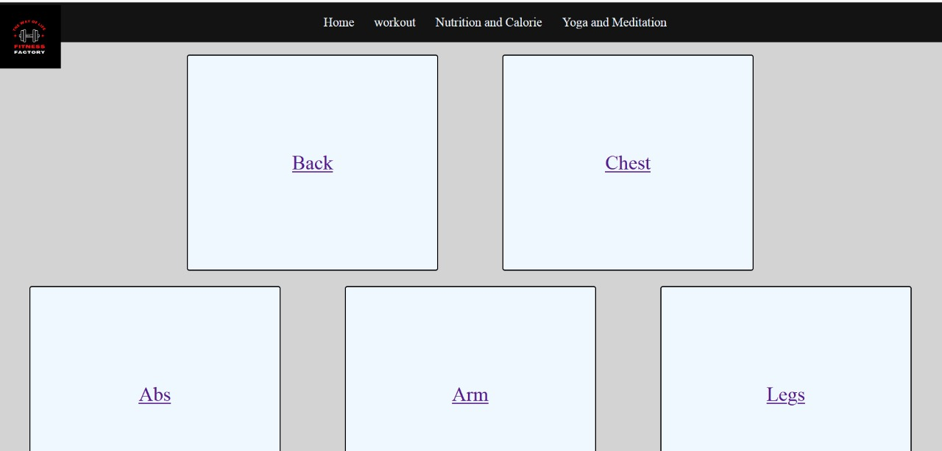

Initial layout

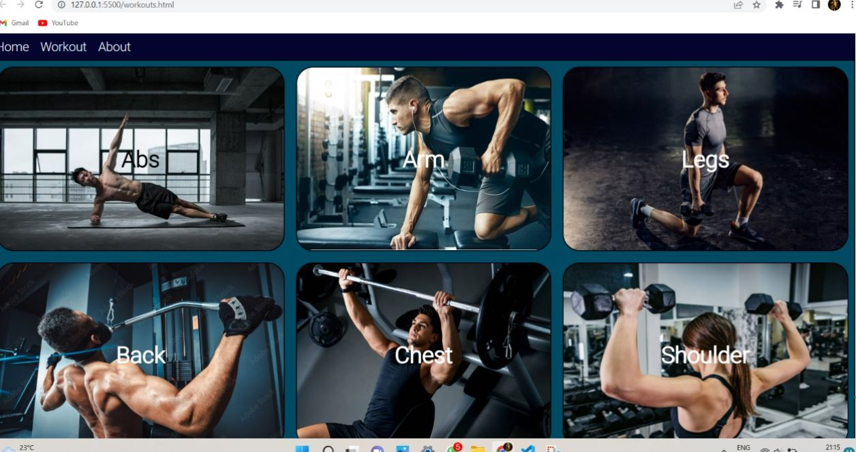

Final

layout

On clicking on any type of workout (for example, here Arm) , we can get access not only to the information but also to the video of the specific 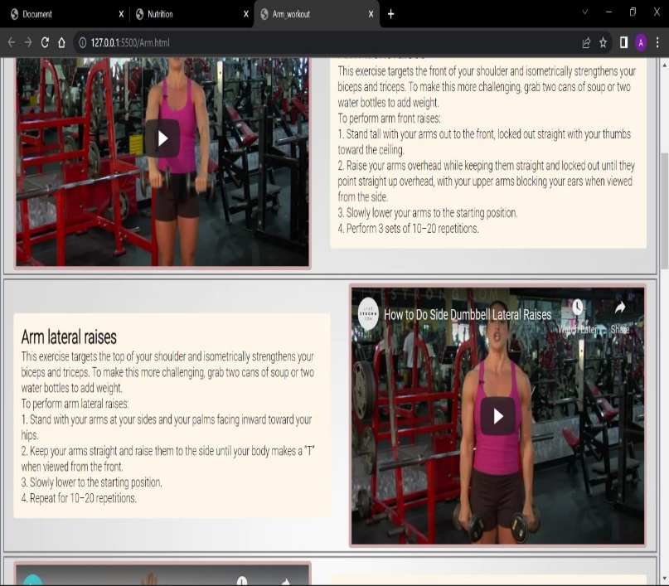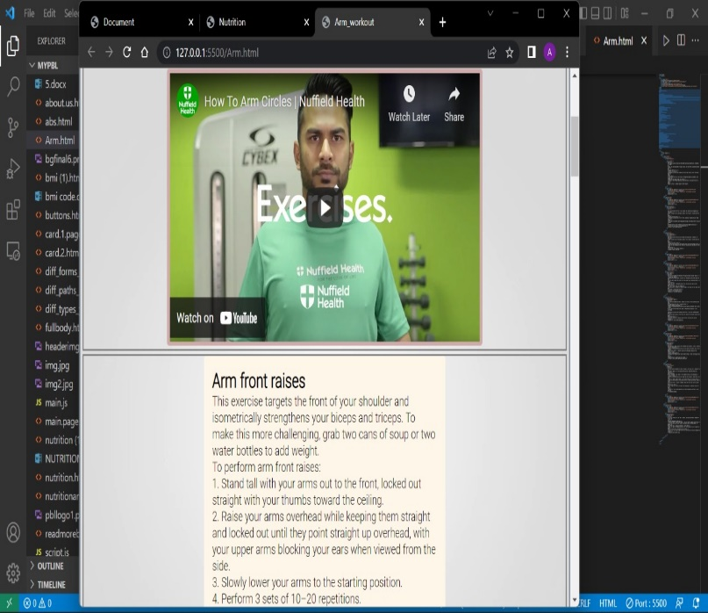workout.

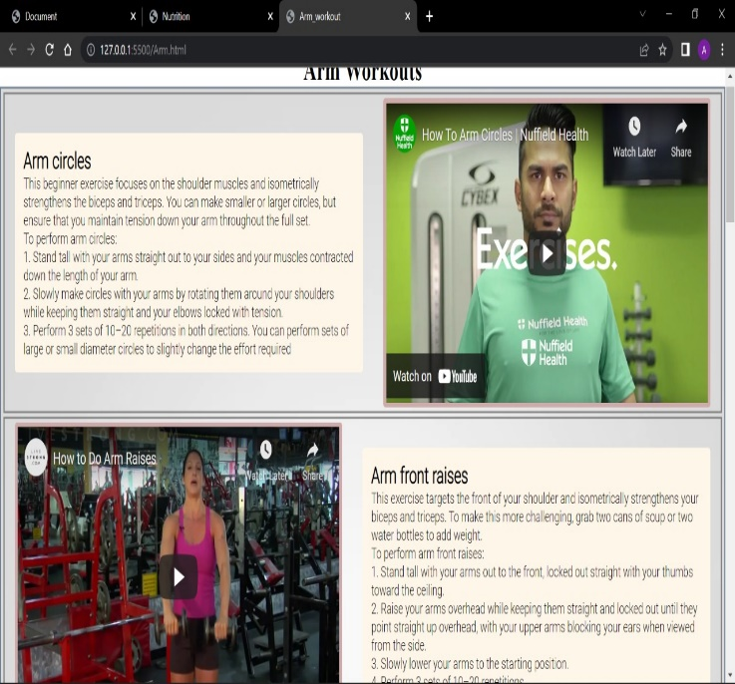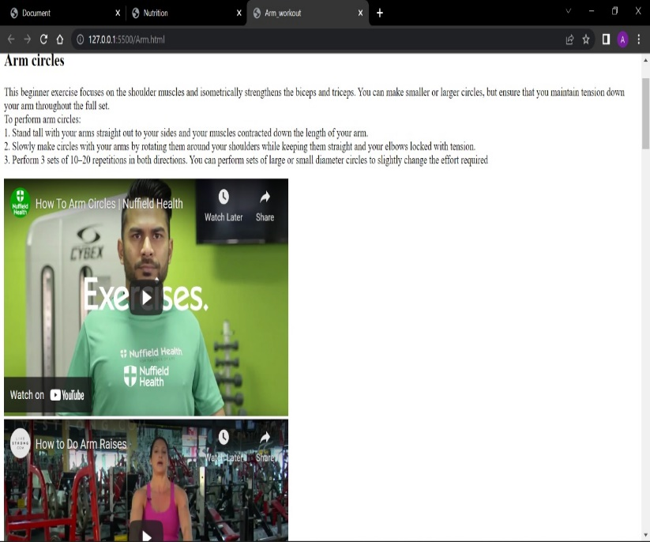

* **Designing the yoga page**

Initially, information about yoga and meditation was inserted using HTML and then was the page was designed in an attractive manner using CSS.

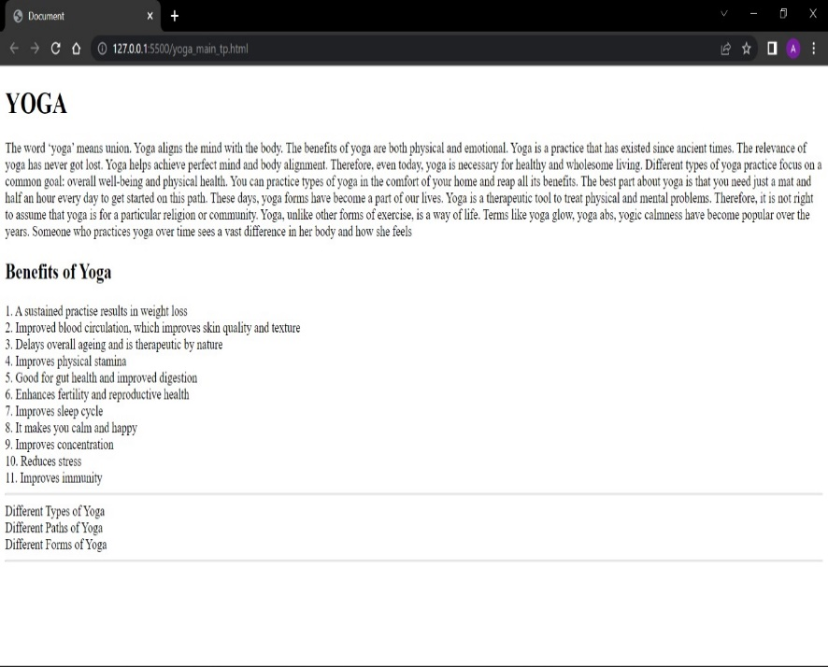

Initial layout

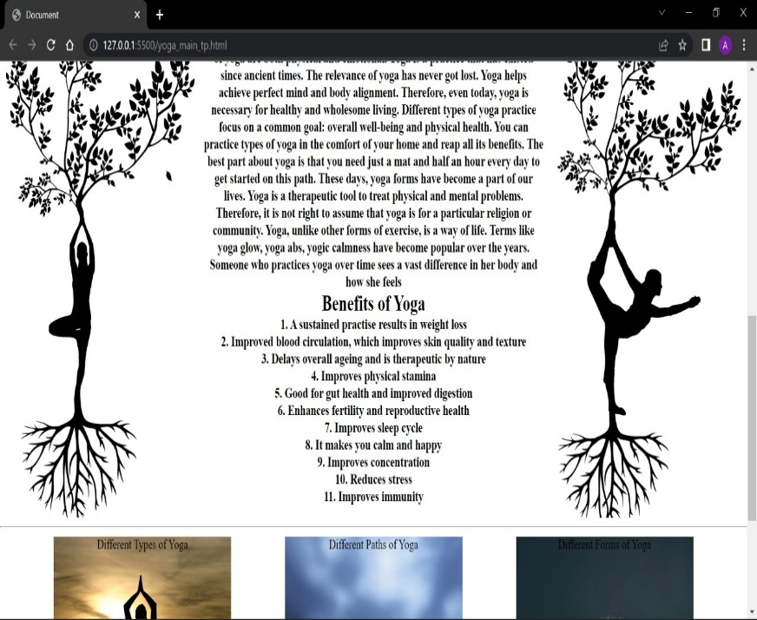

Final layout

* **Designing the nutrition page**

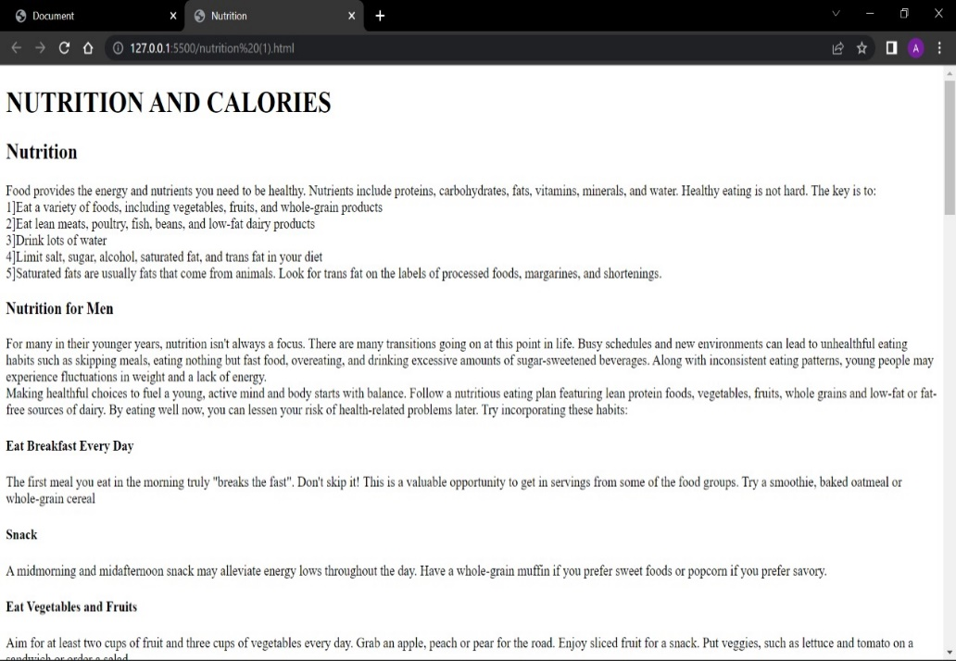



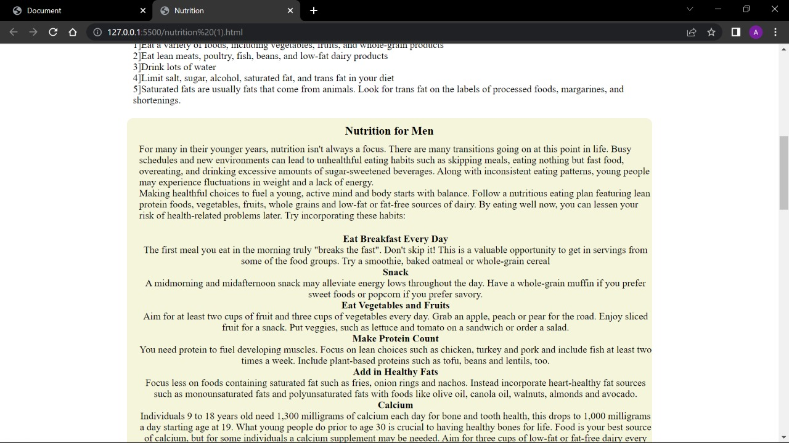

* **Designing the about us page**

It consists the name and photo of the creators of the website.

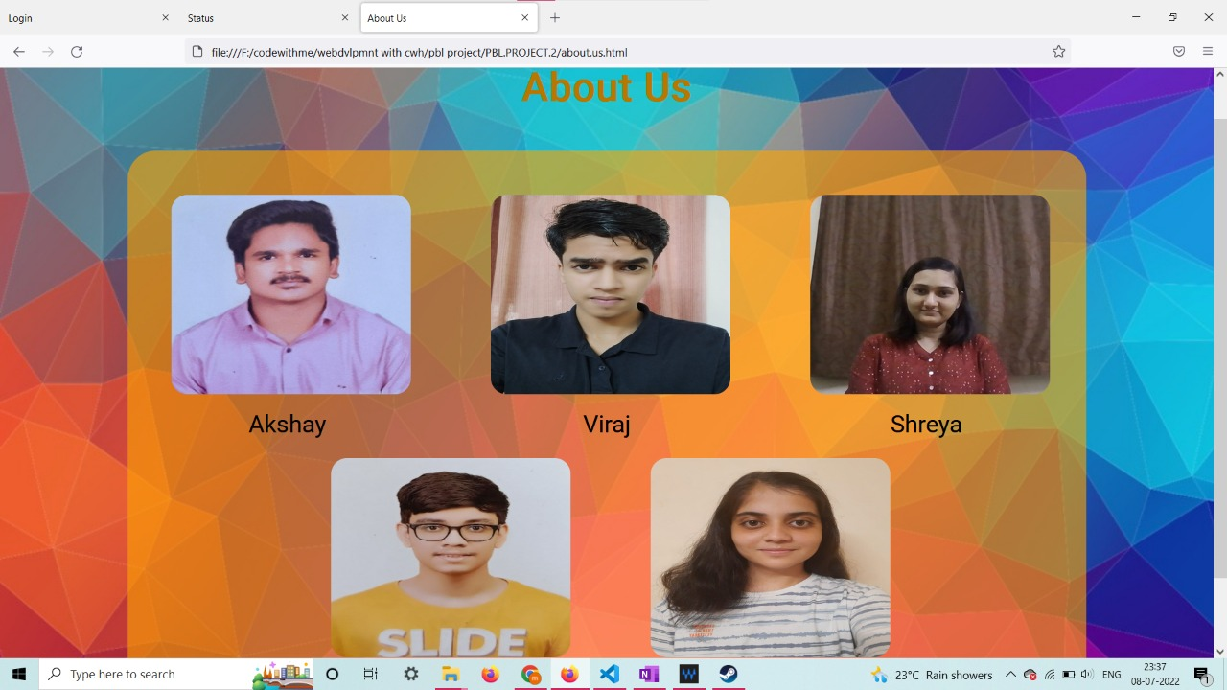

* **Designing the Fitness calculator**

It is made using CSS, HTML and JS. It consists of an ideal weight and a bmi calculator.

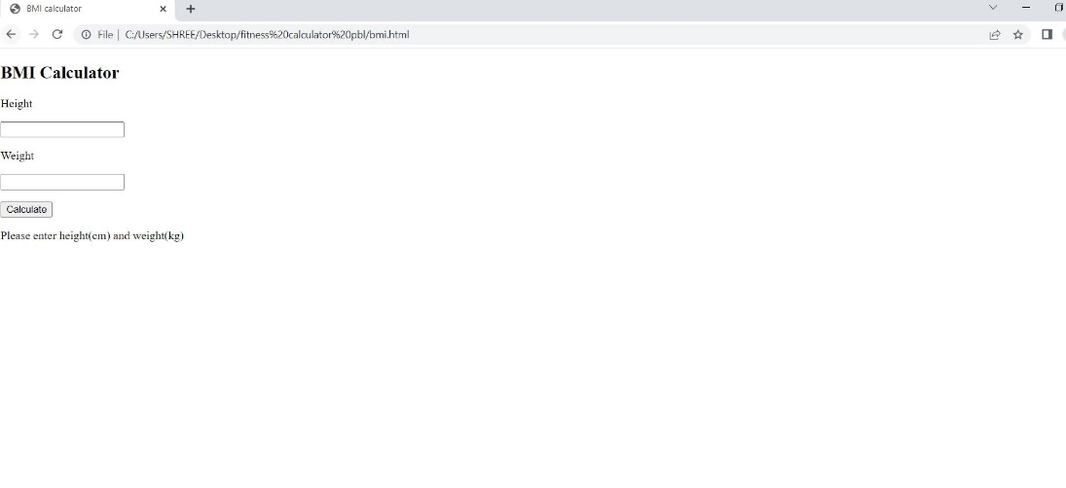 Initial layout

(using html)

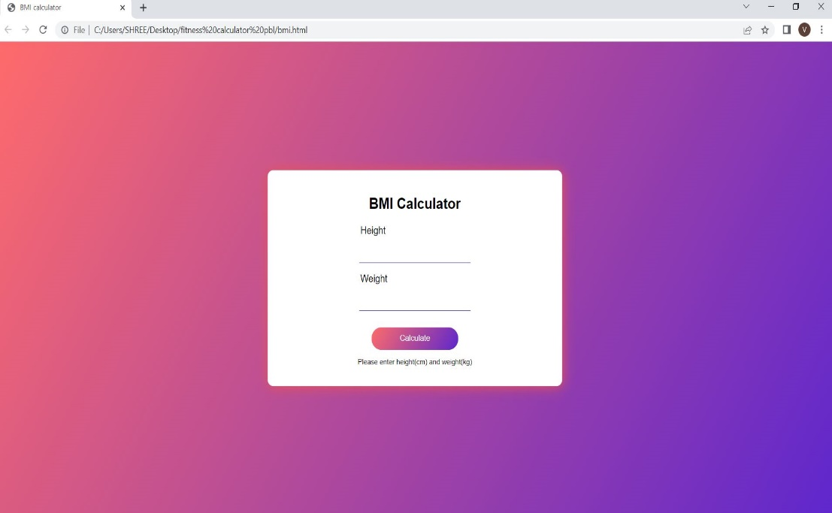

Final layout

(using css)

Chapter 5

**CONCLUSION**

Obesity is a major issue for health departments all over the world. Despite a great effort, the obesity rate is higher than ever before.

The individuals can be motivated to increase their physical activity through behavioral interventions.

It identified that features such as goal-setting, monitoring, information about various exercises, reference workout videos can impact upon the fitness of users by encouraging them to become more involved in physical activity.

This systematic literature review makes it evident that fitness technology has the potential to play a greater role in the health and fitness of the individual because of these features.

So ultimately our website gives the importance of health and guides the user how to take care of their health.

It contains a home page that gives a brief idea about our website

It contains a section “workout” that allows the user to get access to the information about various exercises.

One section provides important information on nutrition and calorie.

We have embedded some fitness related calculators in a section named “fitness calculators”. One section provides information on yoga and meditation. We have embedded video links that will guide the user to do the following activity. The “about us” section will give the user the information about the website creators.

Chapter 6

**REFERENCES**

These are the following sources that we referred to:

For information:

* <https://www.healthifyme.com/in/>
* <https://www.articlecity.com/>
* <https://www.fitnessblender.com/>
* <https://www.livestrong.com/>
* <https://www.articlecity.com/>

For images:

* <https://pixabay.com/>

For videos:

* Youtube links